SmartRide – University-Based Carpooling Platform
A Mini Project Report Submitted in the partial fulfillment of the requirements for the award of the degree of

BACHELOR OF TECHNOLOGY

In
DEPARTMENT OF COMPUTER SCIENCE ENGINNERING
By
1. Raavi Jahnavi — 2420030173
2. Sagar Mounitha Thirumala Reddy — 2420030330
- SriHansika Saraf — 2420030556

Under the Esteemed Guidance of

Ms. Navyatha Ravi





K L (Deemed to be) University
DEPARTMENT OF COMPUTER SCIENCE ENGINEERING

DECLARATION

- The Mini Project Report entitled “SmartRide – University-Based Carpooling Platform “is a record of Bonafide work of Raavi Jahnavi — 2420030173 ,Sagar Mounitha Thirumala Reddy — 2420030330, SriHansika Saraf — 2420030556. submitted in partial fulfillment for the award of B. Tech in Computer Science and Engineering to the K L University. The results embodied in this report have not been copied from any other departments/University/Institute.

Raavi Jahnavi — 2420030173
Sagar Mounitha Thirumala Reddy — 2420030330
SriHansika Saraf — 2420030556

K L (Deemed to be) University
DEPARTMENT OF COMPUTER SCIENCE ENGINEERING
CERTIFICATE

This is certify that the mini project based report entitled “SmartRide – University-Based Carpooling Platform” is a bonafide work done and submitted by Raavi Jahnavi — 2420030173 ,Sagar Mounitha Thirumala Reddy — 2420030330, SriHansika Saraf — 2420030556. in partial fulfillment of the requirements for the award of the degree of BACHELOR OF TECHNOLOGY in Department of Computer Science Engineering, K L (Deemed to be University), during the academic year 2026-2027.

Signature of the Course Co-ordinator Signature of HOD

ACKNOWLEDGEMENT

The success in this project would not have been possible but for the timely help and guidance rendered by many people. Our wish to express my sincere thanks to all those who has assisted us in one way or the other for the completion of my project.

Our greatest appreciation to my guide, Ms. Navyatha Ravi, Department of Computer Science which cannot be expressed in words for his/her tremendous support, encouragement and guidance for this project.

We express our gratitude to Dr. P.Venkateshwar Sir (CSE), Head of the Department for Computer Science Engineering for providing us with adequate facilities, ways and means by which we are able to complete this project-based Lab.

We thank all the members of teaching and non-teaching staff members, and also who have assisted me directly or indirectly for successful completion of this project. Finally, I sincerely thank my parents, friends and classmates for their kind help and cooperation during my work.

Raavi Jahnavi — 2420030173
Sagar Mounitha Thirumala Reddy — 2420030330
SriHansika Saraf — 2420030556

TABLE OF CONTENTS

S.No. | Contents
1. | Abstract
2. | Introduction
3. | Literature survey
4. | Problem Statement and Objectives
5. | Hardware and Software requirements
6. | Implementation
7. | Results & Discussion
8. | Conclusion & Future Scope
9. | References

- ABSTRACT

SmartRide – University-Based Carpooling Platform is a proposed web-based application designed to connect university students and other authorized campus users who travel along similar routes. Many commuters use separate vehicles despite having similar destinations, leading to increased travel expenses, inefficient vehicle utilization, and traffic congestion. Informal ride-sharing arrangements also lack a centralized mechanism for managing users, rides, and bookings.
The proposed platform adapts a microservices-based carpooling system to a university environment. Faculty authorization is intended to control access to the platform, helping ensure that only approved users can participate. The core system supports user authentication, ride creation and management, ride searching, seat availability, booking, and cancellation. The planned architecture separates user management, ride management, booking, and notification functionalities into independent services. Spring Cloud Gateway and Eureka are intended to support API routing and service discovery, while JWT-based authentication and role-based authorization support secure access.
The project aims to provide a structured and convenient way for authorized university commuters to coordinate shared journeys. By combining campus-oriented access control with modular service architecture, SmartRide seeks to improve ride coordination, reduce individual commuting costs, and encourage better utilization of available vehicle seats. Implementation and testing results will be documented according to the actual features completed by the project team.
Team Name: Team-20
Team Logo (if any):
Team Members:
Raavi Jahnavi — 2420030173
Sagar Mounitha Thirumala Reddy — 2420030330
SriHansika Saraf — 2420030556

- INTRODUCTION

Transportation is an important part of daily university life, as students and faculty members travel to and from campus. When multiple commuters follow similar routes, travelling in separate vehicles can lead to unnecessary fuel expenses, inefficient use of vehicle seats, and increased traffic congestion. Informal arrangements through personal contacts and messaging groups may also make it difficult to coordinate ride timings, seat availability, and booking details.
SmartRide – University-Based Carpooling Platform aims to provide a centralized platform for coordinating shared journeys within a university community. Unlike a general-purpose carpooling application, the proposed system incorporates faculty authorization as a university-specific access-control requirement. Approved users can access the relevant features according to their assigned roles and permissions.
The core functionalities include user management, ride creation, searching for available rides, booking seats, cancellation, and notifications. The proposed backend follows a microservices architecture, separating user, ride, booking, and notification responsibilities. API Gateway routing, service discovery, and secure authentication are incorporated into the planned architecture to support modularity and maintainability.
The primary objective is to simplify campus commuting by enabling authorized users to identify suitable rides and coordinate journeys efficiently. This report presents the related work, problem statement, project objectives, hardware and software requirements, implementation approach, results, and future enhancements of the proposed system.

- LITERATURE SURVEY

3.1 UniPool – Campus Carpooling Platform
UniPool is a carpooling platform developed around university students and campus travel. It enables users to find rides, connect with other commuters, and share travel expenses. Its campus-focused approach is relevant to SmartRide because it demonstrates how ride-sharing can be organized within a university community. SmartRide extends this concept by incorporating faculty authorization and a microservices-based backend architecture.
Website: https://unipool.in/

3.2 CampusRide – College and University Carpooling
CampusRide is a college-oriented carpooling platform that focuses on connecting students travelling along similar routes. Its features include campus-related user verification, ride searching, and sharing commuting costs. This approach is relevant to the proposed system because university membership and trust are important considerations for campus transportation. SmartRide proposes faculty-controlled access as an additional university-specific requirement.
Website: https://www.campusride4u.in/

3.3 BlaBlaCar – Online Carpooling Platform
BlaBlaCar enables drivers to publish trips and allows passengers to search for suitable journeys and book available seats. It provides features for managing rides and communicating booking-related information. This platform demonstrates the importance of structured ride creation, seat availability, and booking management. SmartRide adopts similar core carpooling concepts while focusing on authorized university users.
Website: https://www.blablacar.in/

3.4 Towards Sustainable Commuting: Development of a Carpool Ride-Sharing Platform with Real-Time Tracking and Safety Features
Kanagasabai et al. (2025), as cited in the original project presentation, discuss a carpooling platform with an emphasis on sustainable commuting, tracking, and safety. The work uses a layered architecture that separates presentation, business logic, and data management. It provides a reference for organizing the major components of a ride-sharing application. SmartRide focuses on separating major functionalities into microservices and introducing university-specific authorization.
Reference details and publication URL should be verified against the original paper before final submission.

3.5 Design of Architecture for Carpooling Based on Flexible Pickup and Delivery Locations
Zhao et al. (2021), as cited in the original project presentation, examine carpooling architecture with flexible pickup and delivery locations. The work also considers service-quality assessment and KPI-based reporting. It highlights the importance of accommodating practical journey requirements within a carpooling system. SmartRide focuses on campus users, authorization, ride management, and modular service organization.
Reference details and publication URL should be verified against the original paper before final submission.

3.6 Real-time Smart Car Pooling and Ride Sharing System
The original project presentation cites an IJRAR survey published in 2020 under the title “Real-time Smart Car Pooling and Ride Sharing System.” The work discusses smart carpooling approaches and mobile-based ride-sharing architecture. It provides background on the need for better coordination and tracking in shared transportation. SmartRide addresses structured university-based ride coordination with a proposed microservices architecture.
The complete author, journal, volume, issue, page numbers, and URL should be confirmed from the original publication.

- Problem Statement and Objectives

Problem Statement: University commuters need a secure and organized way to share rides with authorized campus users travelling along similar routes.

Problem Description: Informal commuting arrangements make it difficult to coordinate rides, available seats, bookings, and cancellations. A university-based platform with faculty-controlled access can provide a structured approach to managing ride-sharing among approved users.

Objectives:
- To develop a centralized carpooling platform for university commuters.
- To incorporate faculty authorization for access to the platform.
- To allow authorized drivers to create and manage rides by specifying routes, dates, times, and available seats.
- To enable passengers to search for suitable rides and book available seats.
- To support ride booking management and cancellation.
- To implement secure authentication and role-based authorization.
- To organize backend functionalities into User, Ride, Booking, and Notification microservices.
- To use API Gateway routing and service discovery in the proposed architecture.
- To encourage better vehicle-seat utilization and reduce individual commuting expenses.

- HARDWARE AND SOFTWARE REQUIREMENTS
Hardware Requirements:
- Processor: Intel Core i3 or equivalent and above.
- RAM: Minimum 4 GB; 8 GB or above recommended.
- Storage: Minimum 10 GB of available storage for project files, dependencies, and databases.
- Network: Internet or local network connectivity for service communication and testing.
- Client device: Desktop or laptop with a modern web browser.
Software Requirements:
- Operating System: Windows, Linux, or another supported development operating system.
- Programming Language: Java.
- Backend Framework: Spring Boot.
- Microservices and Routing: Spring Cloud Gateway.
- Service Discovery: Netflix Eureka through Spring Cloud.
- Authentication: JWT-based authentication and role-based authorization, as planned.
- Frontend: Specify the actual frontend technologies used by the team.
- Database: Specify the actual database selected by the team.
- Build Tool: Specify Maven or Gradle according to the project configuration.
- Development Environment: Specify the IDE used for implementation.
- API Testing: Specify the API testing tool actually used by the team.
- Version Control: Git and GitHub, if used.

- IMPLEMENTATION

1. Frontend (HTML, CSS, JavaScript) and project structure
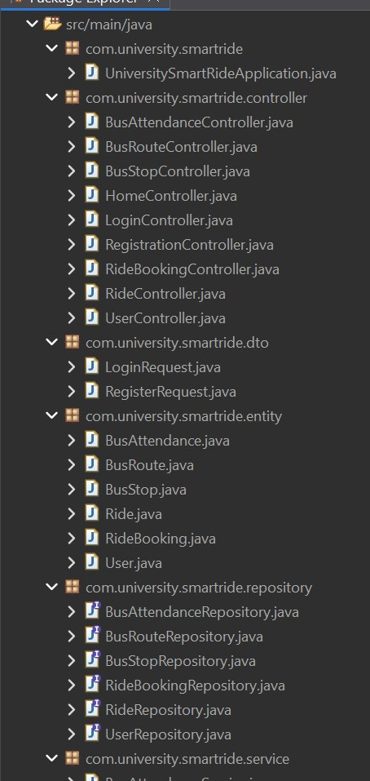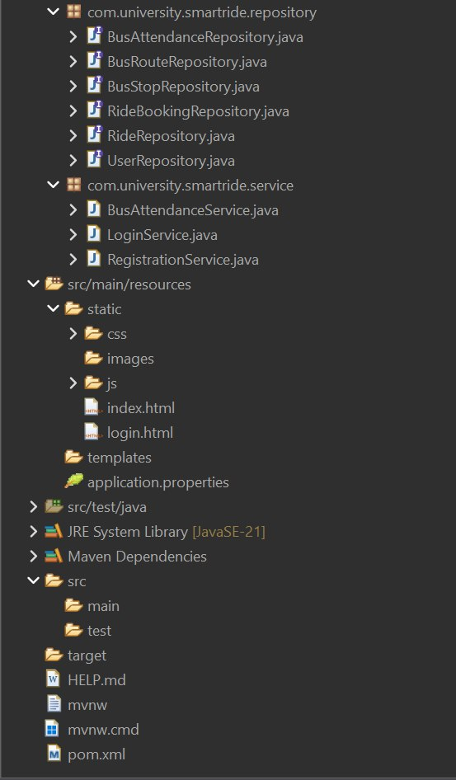
The frontend is developed using HTML, CSS, and JavaScript to provide an interactive interface for university students and faculty members.
1.1 index.html: Implements the home page, ride search, offer ride, and university bus sections.
<h1>Better Rides. Stronger Connections.</h1>
<a href="#find-ride">Find a Ride</a>
<a href="#offer-ride">Offer a Ride</a>
1.2 css/style.css: Defines the layout, colours, buttons, forms, and styling.
body {
font-family: Arial, sans-serif;
background-color: #f8f7f2;
color: #34483a;
}
1.3 login.html: Provides the login and registration forms for university users.
<input type="email" placeholder="University email" required>
<input type="password" placeholder="Password" required>
<button type="submit">Login</button>
1.4 js/ride.js: Handles ride searching, ride publishing, and displaying results.
fetch("/api/rides")
.then(response => response.json())
.then(data => console.log(data));
2. Backend (Java)
The backend is developed using Java and Spring Boot to process requests and manage application data.
2.1 UniversitySmartRideApplication.java: Starts the Spring Boot application.
@SpringBootApplication
public class UniversitySmartRideApplication {
public static void main(String[] args) {
SpringApplication.run(
UniversitySmartRideApplication.class, args);
}
}
2.2 RegistrationController.java: Handles user registration requests.
2.3 LoginController.java: Manages user login operations.
2.4 RideController.java: Handles ride creation and ride-search requests.
2.5 RideBookingController.java: Manages ride bookings.
2.6 BusRouteController.java: Retrieves university bus routes.
2.7 BusStopController.java: Retrieves bus-stop information.
2.8 Entity and Repository Classes: Files such as User.java, Ride.java, RideBooking.java, BusRoute.java, and their corresponding repository classes manage application data and database operations.
3. API Integration
API integration connects the frontend with the Spring Boot backend using HTTP requests and JSON responses.
3.1 JavaScript API Request (ride.js):
fetch("/api/rides")
.then(response => response.json())
.then(rides => {
console.log(rides);
});
3.2 Java API Endpoint (RideController.java):
@GetMapping
public List<Ride> getAllRides() {
return rideRepository.findAll();
}
3.3 Database Integration: MySQL stores user details, rides, ride bookings, bus routes, bus stops, and bus attendance records. Spring Boot repositories are used to access the database
- RESULTS & DISCUSSION

  - Home Page
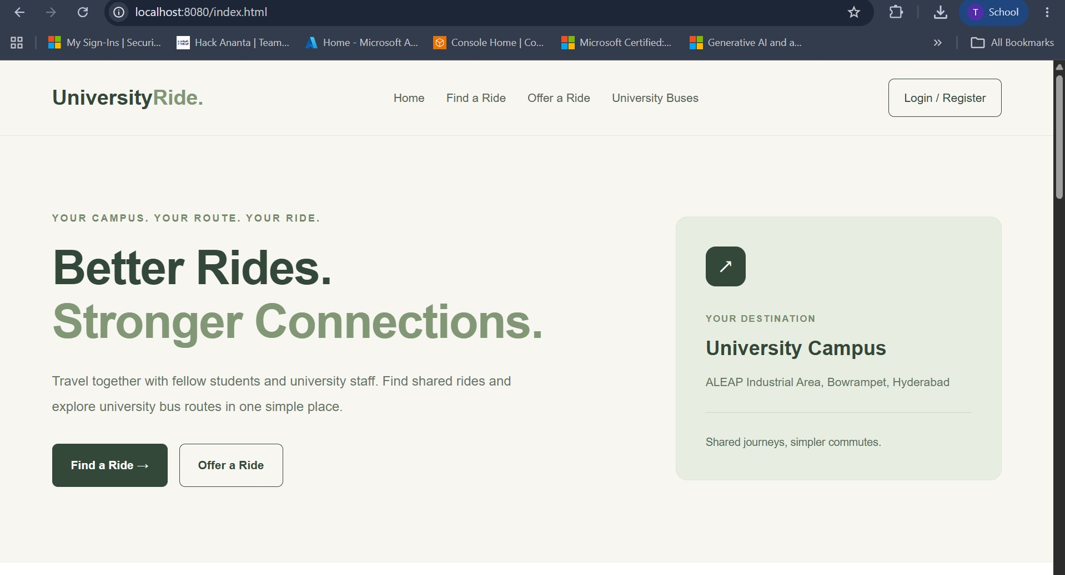

The home page displays the UniversityRide platform, navigation menu, and introduction to university-based carpooling. It provides access to ride searching, ride offering, university bus information, and login or registration.

7.2 User Registration and Login Page
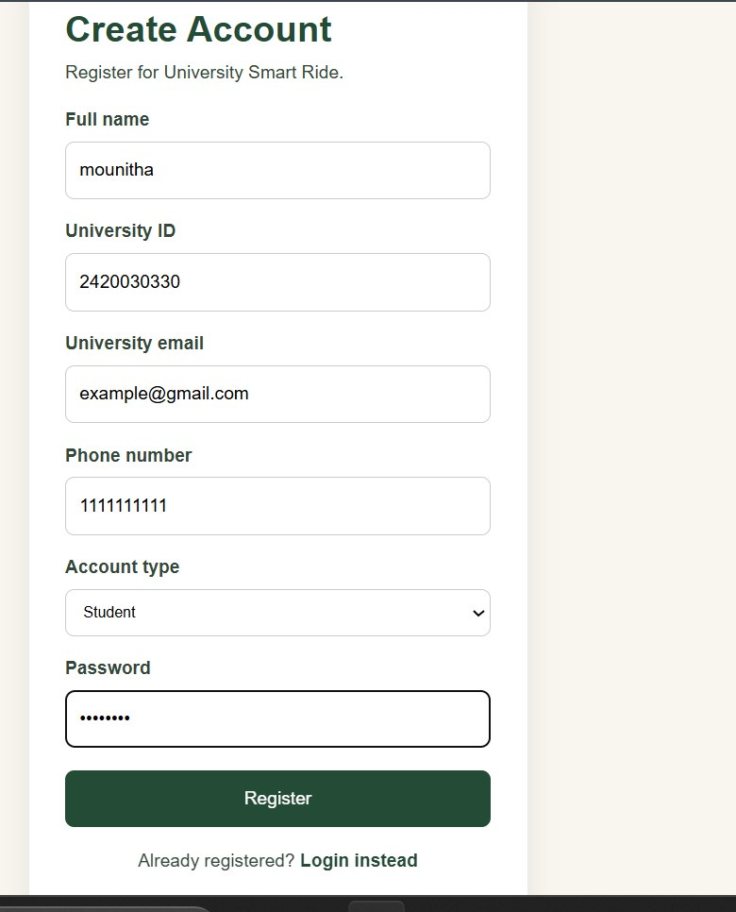

This page allows university users to register or log in using their account details. The registration form collects relevant information, including university ID, email, phone number, account type, and password.

  - Offer a Ride Page

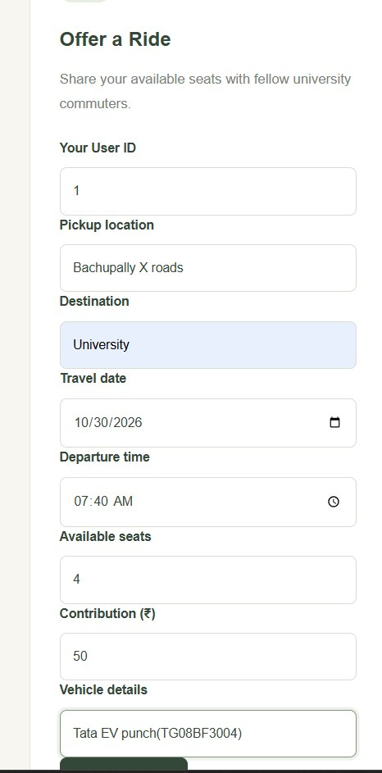

This page allows users to enter pickup location, destination, travel date, departure time, available seats, contribution amount, and vehicle details. The entered information is used to create a ride listing.

7.4 Find a Ride Page
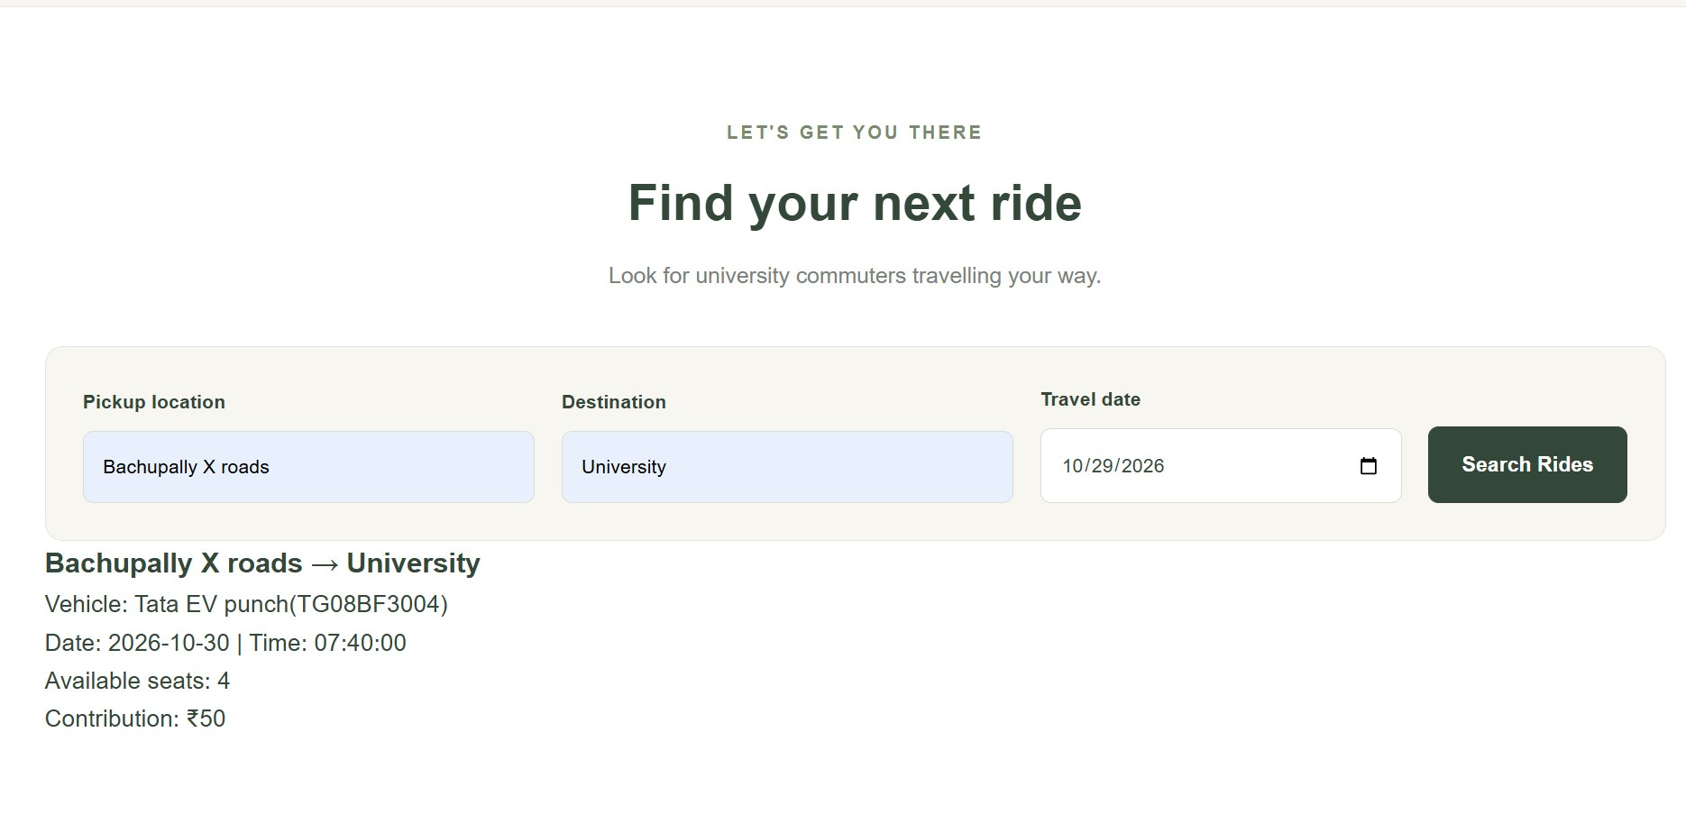

This page allows users to search for rides using their pickup location, destination, and travel date. The results section displays matching rides and their available details.

7.5 Database Tables

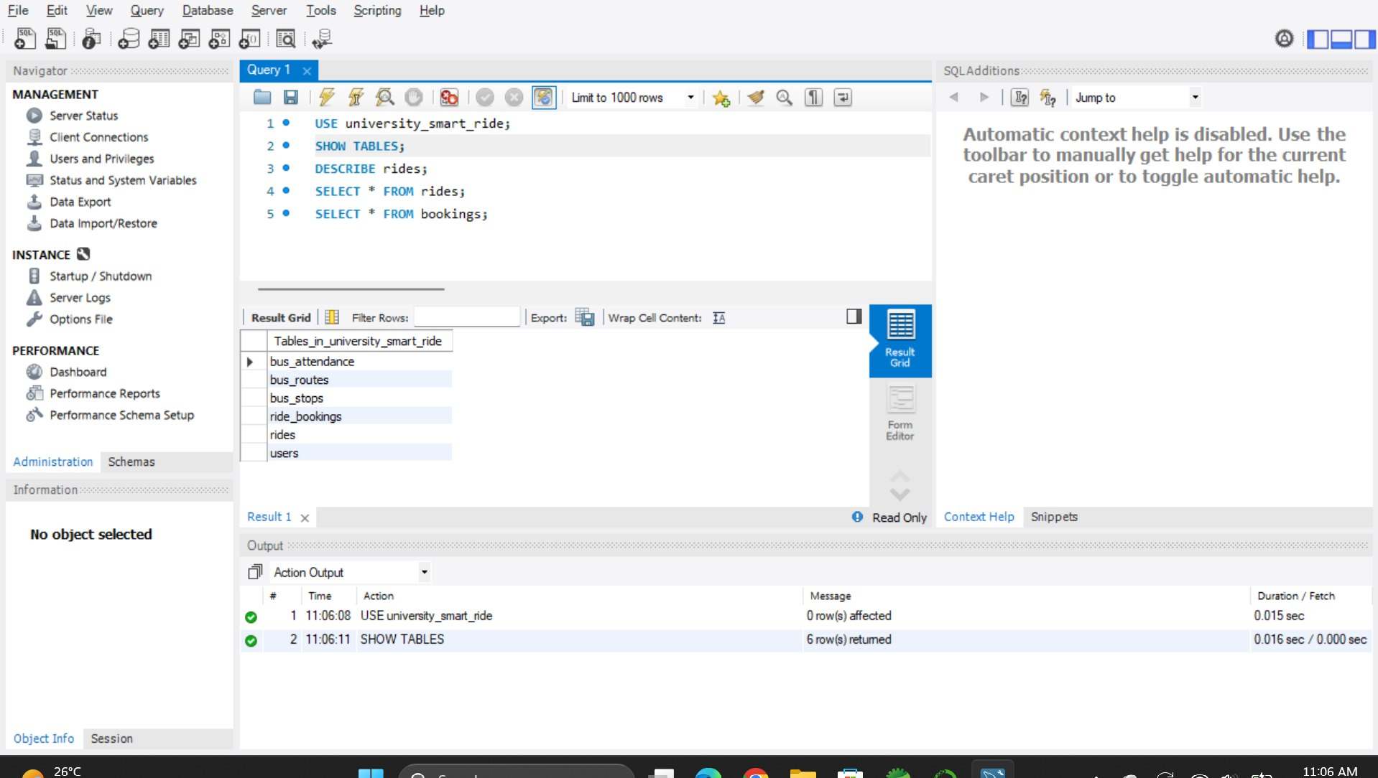

The university_smart_ride database stores information related to users, rides, bookings, bus routes, bus stops, and bus attendance. These tables support the application's data-management operations.
7.6 Ride Records in Database

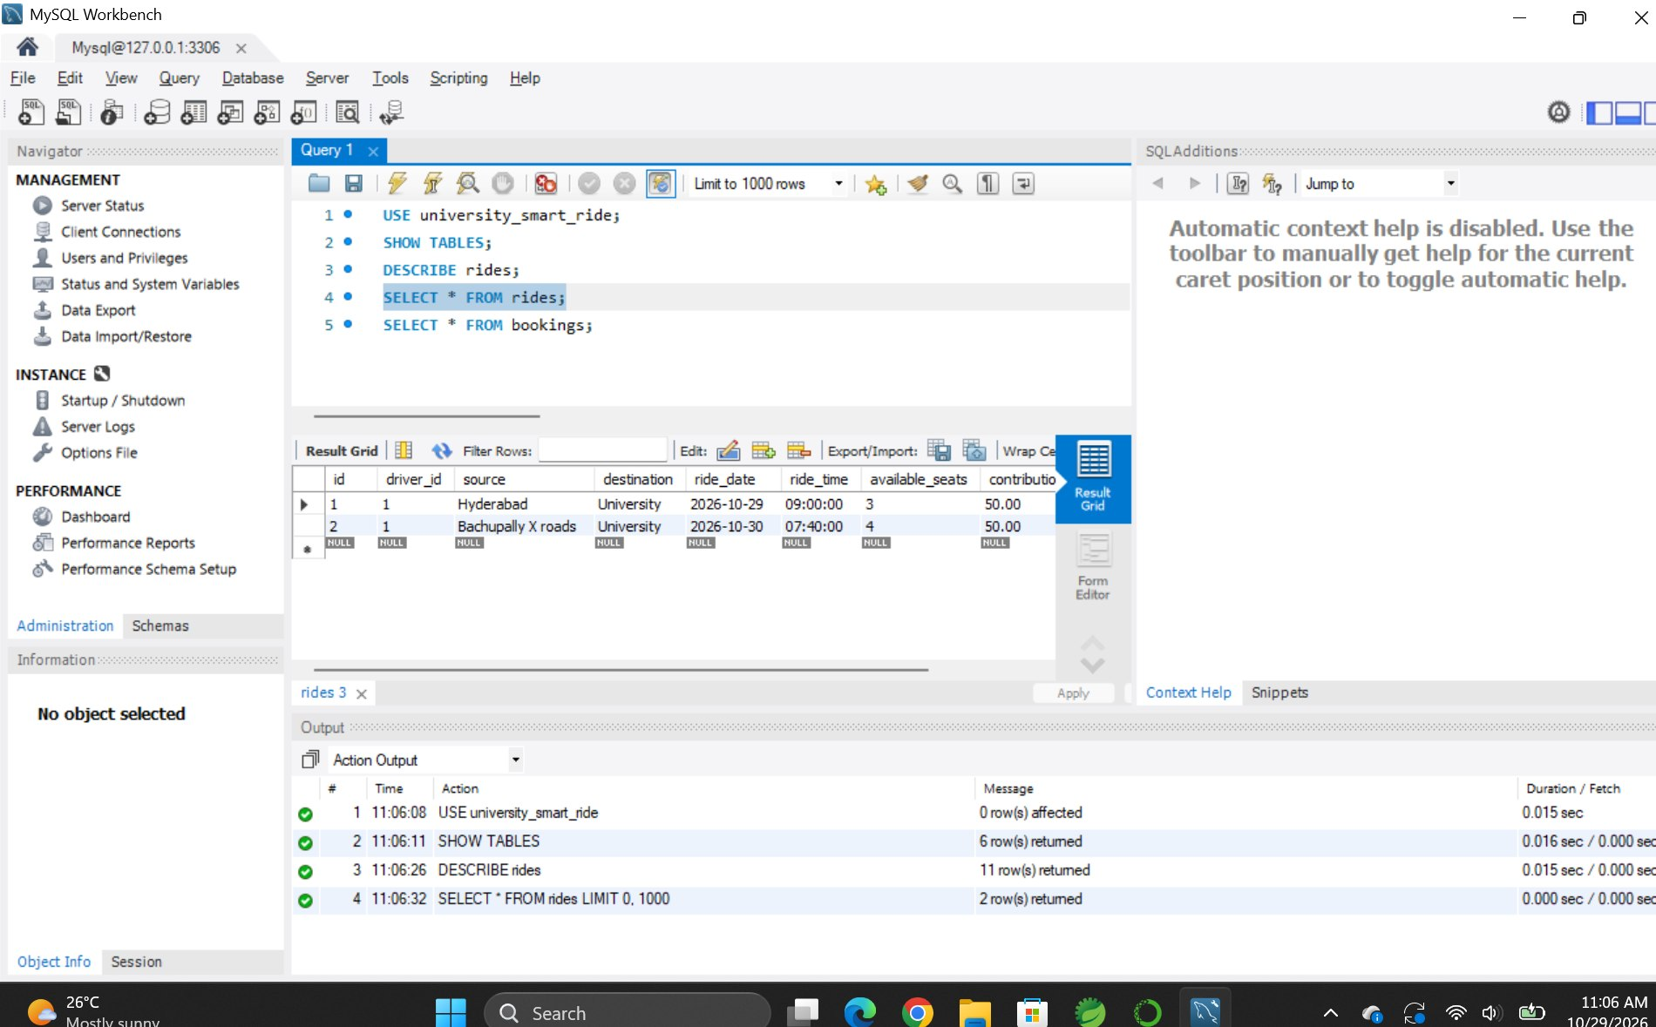

The rides table stores ride information such as source, destination, date, time, available seats, contribution, and vehicle details. These records provide the data required for ride management and searching.

- Conclusion

The University Smart Ride project aims to make transportation easier for university students by providing ride-sharing facilities and university bus information. It uses HTML, CSS, JavaScript, Java Spring Boot, and MySQL to create a web-based transportation platform. The system allows users to search for rides, offer rides, and access transportation details. Overall, the project provides a foundation for convenient and organized campus transportation.

- Future Scope

The project can be improved in the future by adding the following features:
- Mobile Application: Develop an Android and iOS app for easier access.
- GPS Tracking: Provide real-time tracking of rides and university buses.
- Notifications: Send updates about ride bookings and cancellations.
- Secure Login: Improve authentication and user data protection.
- Ratings and Reviews: Allow students to rate rides and provide feedback.
- AI-Based Matching: Recommend suitable rides based on routes and travel times.

- REFERENCES

- UniPool, “Carpool with Your Campus.” Available at: https://unipool.in/
- CampusRide, “College and University Carpooling Platform.” Available at: https://www.campusride4u.in/
- BlaBlaCar India, “Carpooling Platform.” Available at: https://www.blablacar.in/
- Spring, “Spring Cloud Gateway.” Available at: https://spring.io/projects/spring-cloud-gateway
- Spring, “Spring Cloud.” Available at: https://spring.io/cloud/
- Spring, “Spring Guides.” Available at: https://spring.io/guides/
- Kanagasabai et al., “Towards Sustainable Commuting: Development of a Carpool Ride-Sharing Platform with Real-Time Tracking and Safety Features,” IJRISS, 2025. Verify the complete bibliographic details and publication URL before submission.
- Zhao et al., “Design of Architecture for Carpooling Based on Flexible Pickup and Delivery Locations,” Springer, 2021. Verify the complete bibliographic details and publication URL before submission.
- “Real-time Smart Car Pooling and Ride Sharing System,” IJRAR, 2020, as cited in the original project presentation. Verify the authors, journal details, and publication URL before submission.
- Spring Cloud Gateway Documentation, “Spring Security Integration.” Available at: https://docs.spring.io/spring-cloud-gateway/reference/intro.html

